

**Final Project Report**

**Project Name: Dream Travels Website**

**Submitted By:**

|  |  |
| --- | --- |
| **Names** | **Roll No** |
| Ali Amir | 2025-CS-127 |
| Anas Shafi Shahid | 2025-CS-144 |
| Muhammad Uzair | 2025-CS-172 |
| Muhammad Salahudin | 2025-CS-163 |
| Muhammad Ammar Rasheed | 2025-CS-139 |
| Huda Shahzadi | 2025-CS-146 |

**Instructor:**

**Mam Ramsha Khalid**

**Teacher Assistant: Mr. Mudassir**

**Department of Computer Science**

**University of Engineering and Technology, Lahore**

Contents

Dream Travel Agency Website 3

1. Introduction 3

2. Project Objectives 3

3. Tools and Technologies Used 3

4. Website Structure and Navigation 3

5. Detailed Description of Web Pages 4

5.1 Home Page 4

5.2 Destinations Page 5

5.3 Packages Page 7

6. Contact and Communication Features 9

7. Conclusion 10

# **Dream Travel Agency Website**

## **1. Introduction**

Dream Travel Agency Website is a professional travel website designed to help users explore beautiful tourist destinations and choose suitable travel packages. The website provides an attractive and user‑friendly interface where users can view destinations, compare packages, and easily contact the travel agency. The purpose of this project is to demonstrate basic website planning, design structure, and content organization.

## **2. Project Objectives**

The main objectives of this project are:

* To design a simple and attractive travel agency website.
* To provide users with popular National and International destinations.
* To show affordable travel packages clearly so that people utilize it without any issue.
* To make communication easy through contact options.
* Add map option in contact section by which people access us easily.
* To practice website documentation and reporting skills.

## **3. Tools and Technologies Used**

The following tools and technologies are used in this project:

* HTML (for website structure).
* CSS (for styling and layout).
* Google Maps (for location display).

## **4. Website Structure and Navigation**

The Dream Travel Agency website contains four main navigation options:

1. Home
2. Destinations
3. Packages
4. Contact

Each section is clearly organized to provide a smooth browsing experience for users.

## **5. Detailed Description of Web Pages**

### **5.1 Home Page**

The Home page introduces users to the travel agency and highlights selected tourist destinations. Only three featured destinations are displayed here to keep the page simple and attractive. If the user clicks on any destination, then user sees the details of destinations.

**Featured Destinations on Home Page:**

* Istanbul
* Bali
* Hunza

Users can easily navigate to other sections from the Home page. If the user clicks on the more destinations, then the user go to the destinations section where user explore the more cities and countries and easily select the country and we also add the option of help in the page so that any difficulty of user can be easily solved.

**View of home page:**

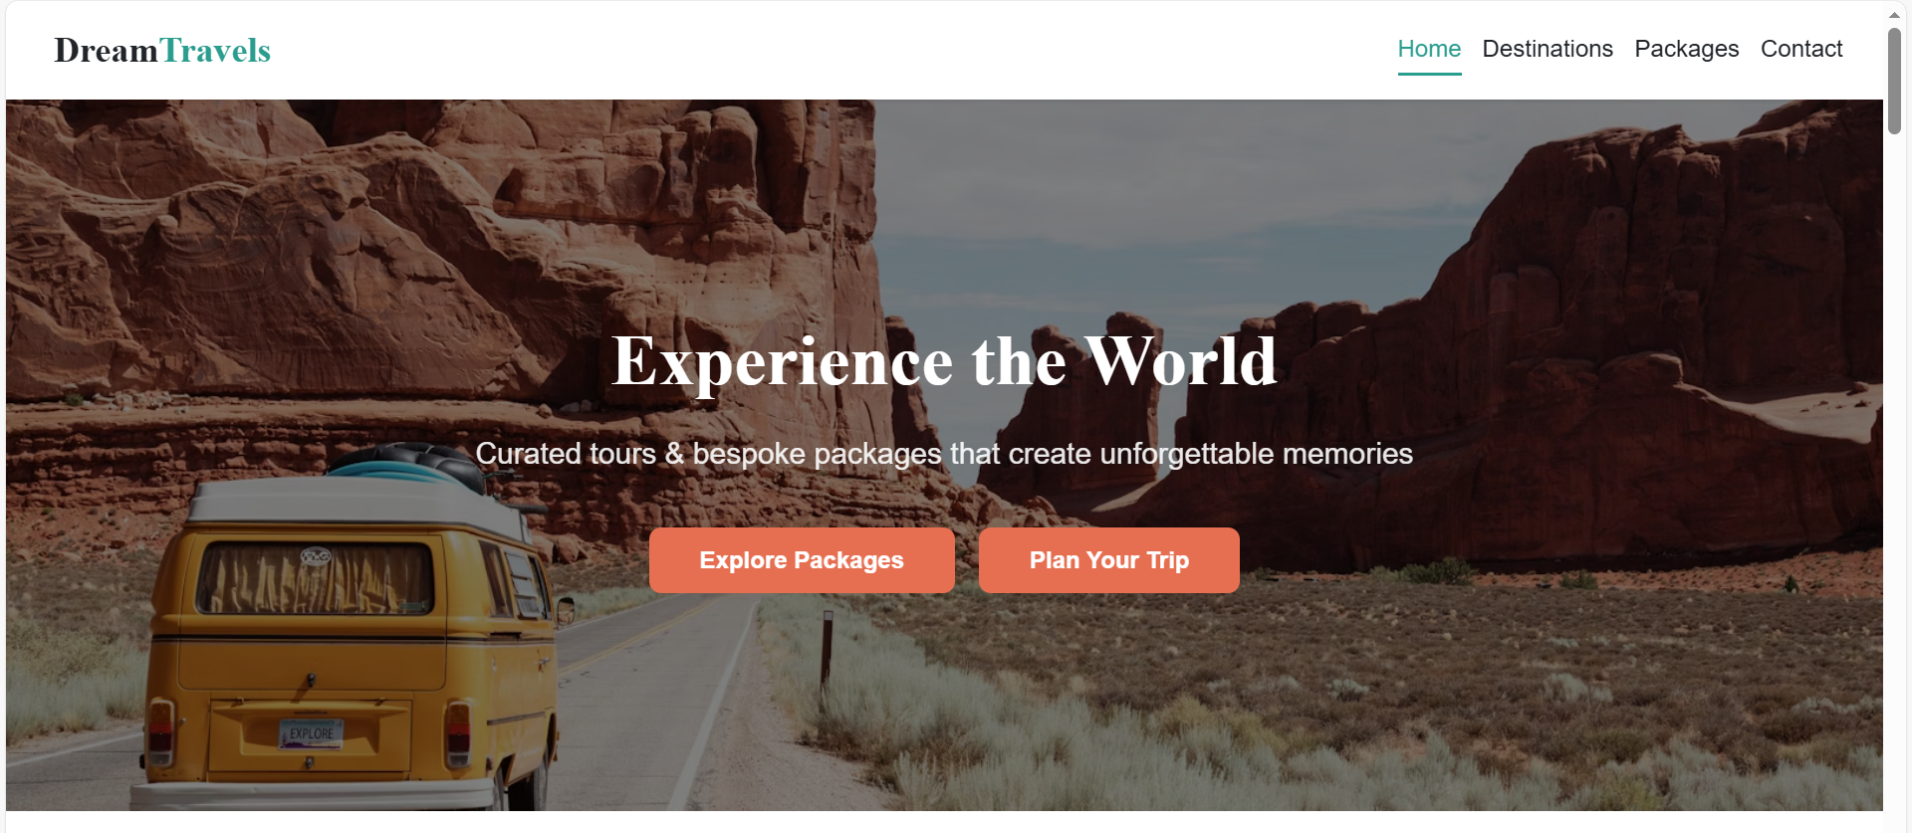

### **5.2 Destinations Page**

The Destinations page displays all available cities offered by Dream Travel Agency. This page provides users with a complete overview of travel options.

**List of Destinations:**

* Istanbul
* Bali
* Hunza
* Swiss Alps
* Kyoto & Tokyo
* Khagan Valley
* Santorini
* South Island

Each destination can include images and short descriptions for better user engagement. We also insert the option of select country. We set five countries and each country contains packages of cities that are relative to it.

**View of Destination page:**

The page is shown as:

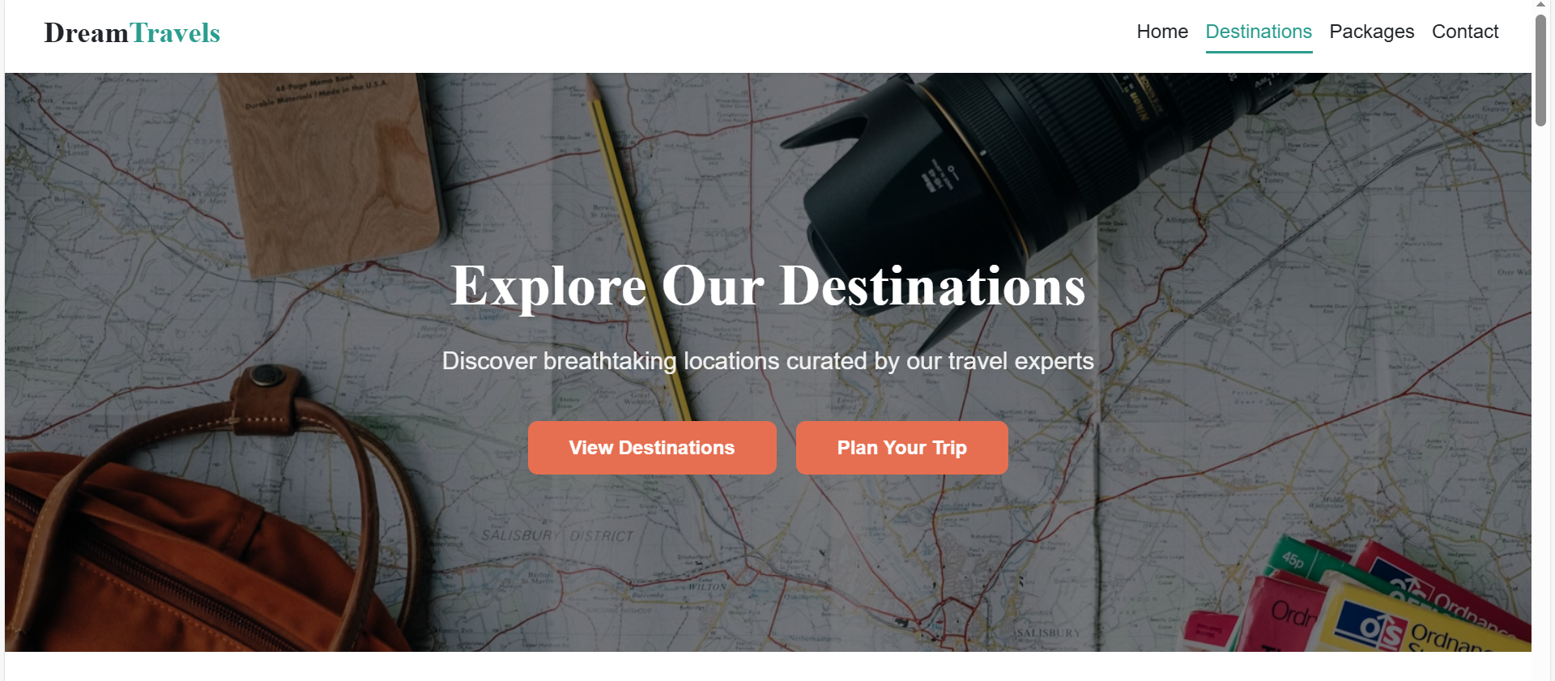

The packages page is shown as:

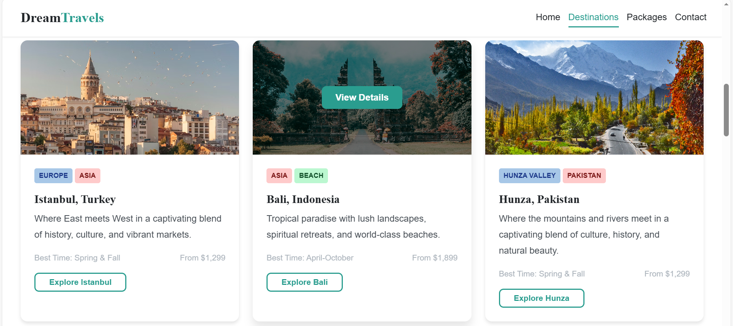

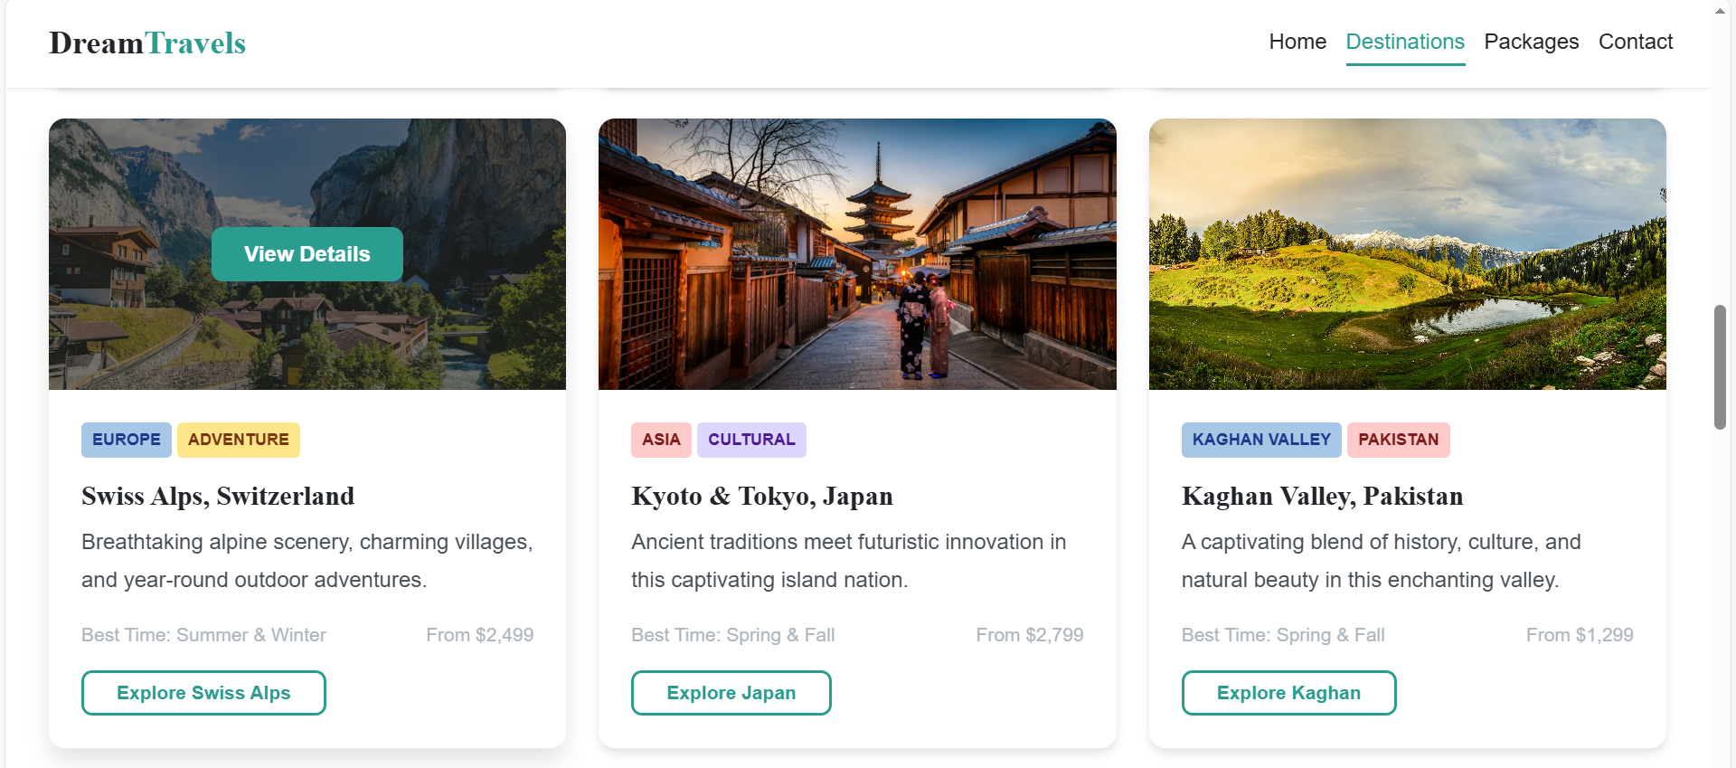

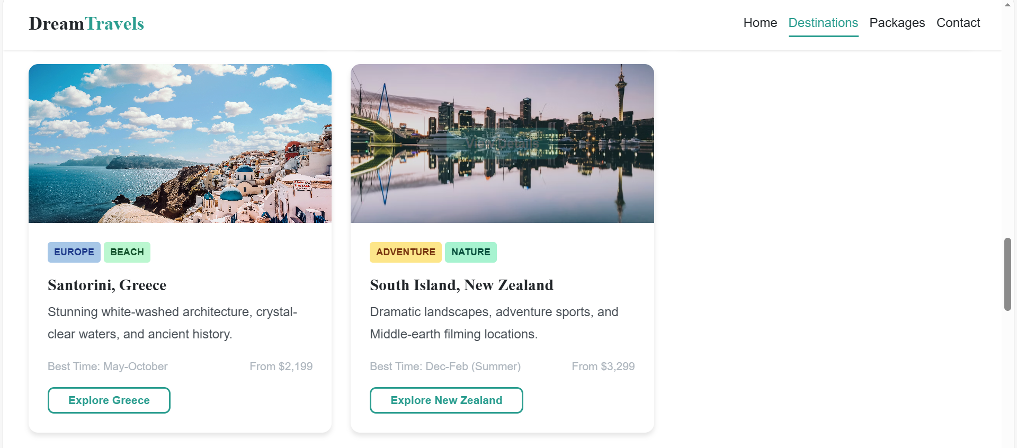

### **5.3 Packages Page**

The Packages page presents three different travel packages designed for different budgets and travel styles.

**Available Packages:**

1. **Explorer Package**  
   *Price:* PKR 9,999  
   Suitable for budget travelers and short trips. This package involves 4-6 days itinerary, 3-Star accommodation, guided city tours, basic travel insurance, meals, airport transfers.
2. **Classic Escape Package**  
   *Price:* PKR 18,999  
   Ideal for comfortable travel with better facilities. This package involves 7-10 days itinerary, 4-Star accommodation, all meals included, 24/7 support line etc.
3. **Premium Voyage Package**  
   *Price:* PKR 34,999  
   Designed for luxury travel with premium services. This package involves 10-14 days itinerary, 5-Star luxury hotels, gourmet dining experience, private chauffeur etc.
4. **Family Fun Package**

*Price:* PKR 24,999

Specially designed for families with children of all ages. Includes kid-friendly activities, accommodations, and flexible schedules.

1. **Adventure Seeker**

*Price:* PKR 15,999

For thrill-seekers and outdoor enthusiasts. Includes adventure activities, outdoor accommodations, and expert guides.

At last of the **packages page**, we make the comparison of packages that we offer and table of meals, duration, accommodation, price (per person), guided tours, transportation, insurance, support, customization. By this comparison, it is easy for the people to choose the package according to their demands. And further we added option of check details of packages again so that user simply clicks the option and can see details of the particular package where information is explained in detail.

We also insert the option that users also customize their plans by contacting us and we then will make a custom trip plan according to their demands.

**View of Packages Page:**

The packages page is shown as:

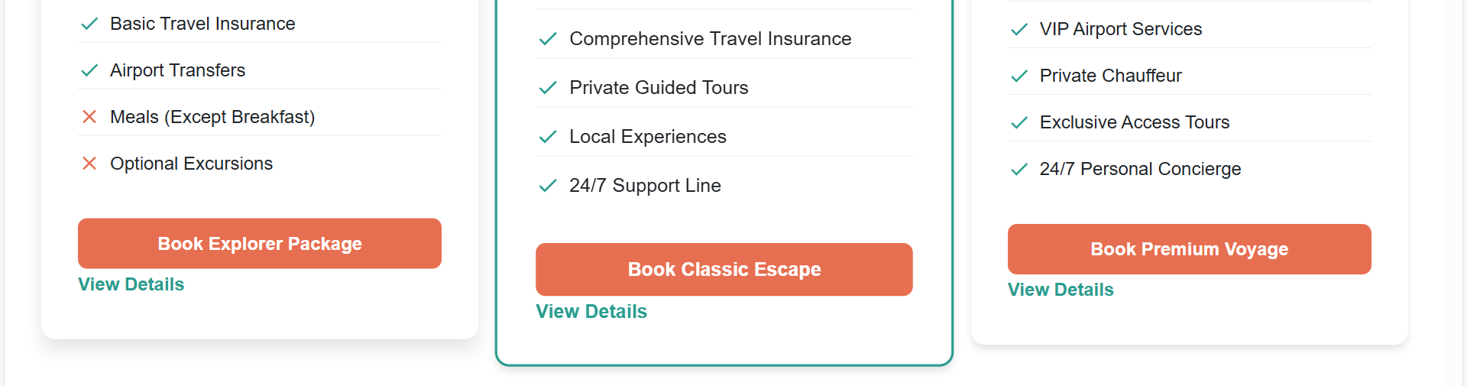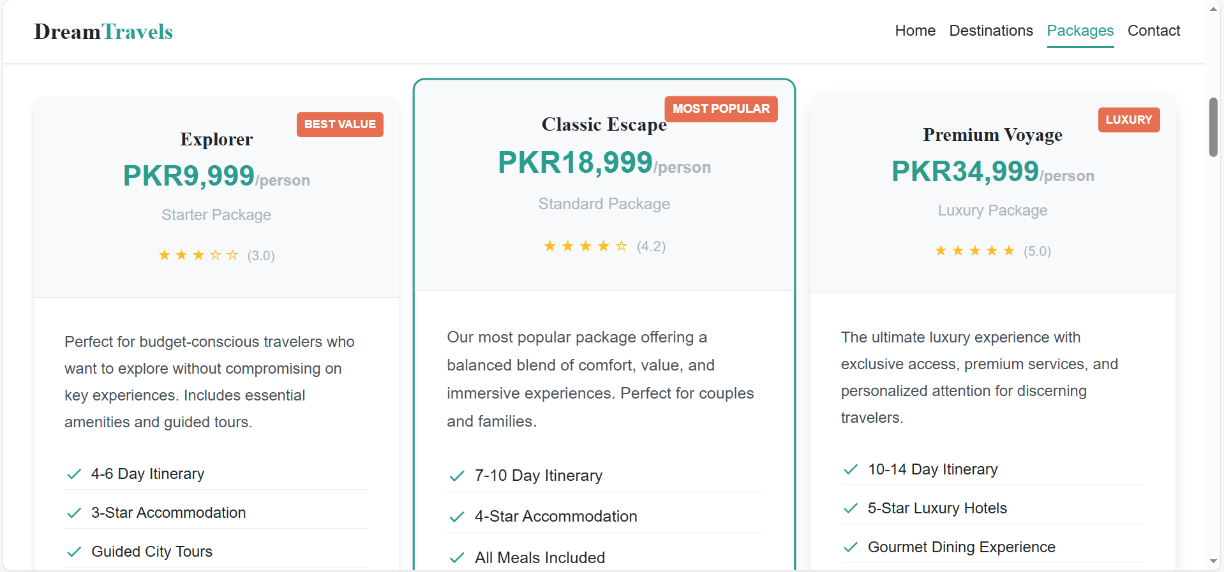

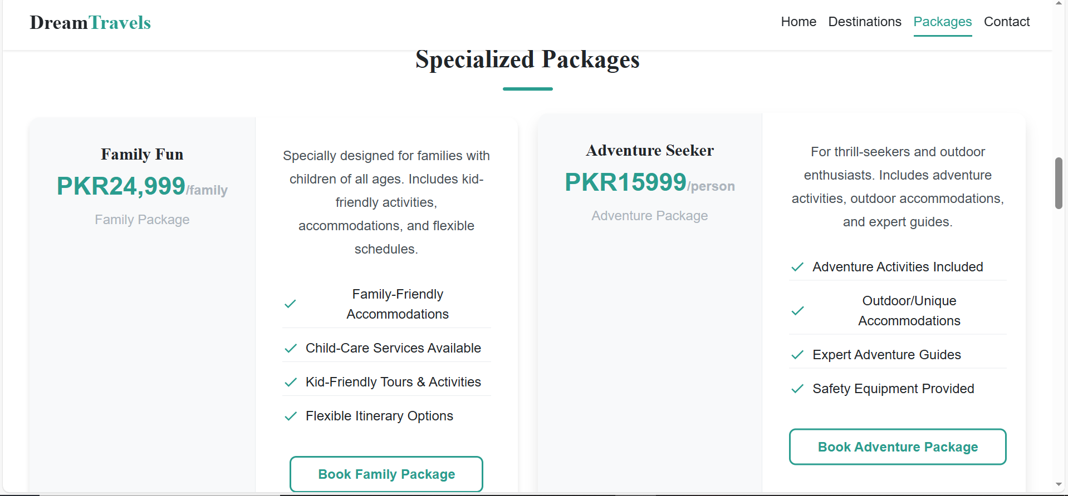

## **6. Contact and Communication Features**

The Contact page allows users to easily communicate with the travel agency.

**Contact Page Features:**

* Message form for user queries.
* Google Map showing our agency location.
* **“Call Us”** option (phone number).
* **“Email Us”** option (official email address).
* **“Visit Us”** option (office address).

This page ensures trust and accessibility for customers. We also added the frequently asked questions at the end of the contact page for the benefit of users and if user clicks on any question, then the suitable answer is shown to the user from which people can find solutions to their problems.

**View of Contact Page:**

The contact is shown as:

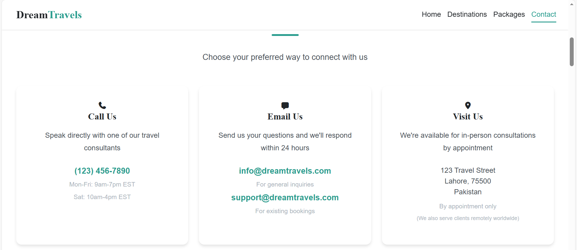

Now, the map and send message view is given as:

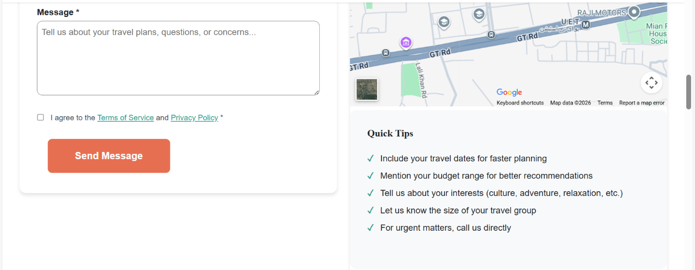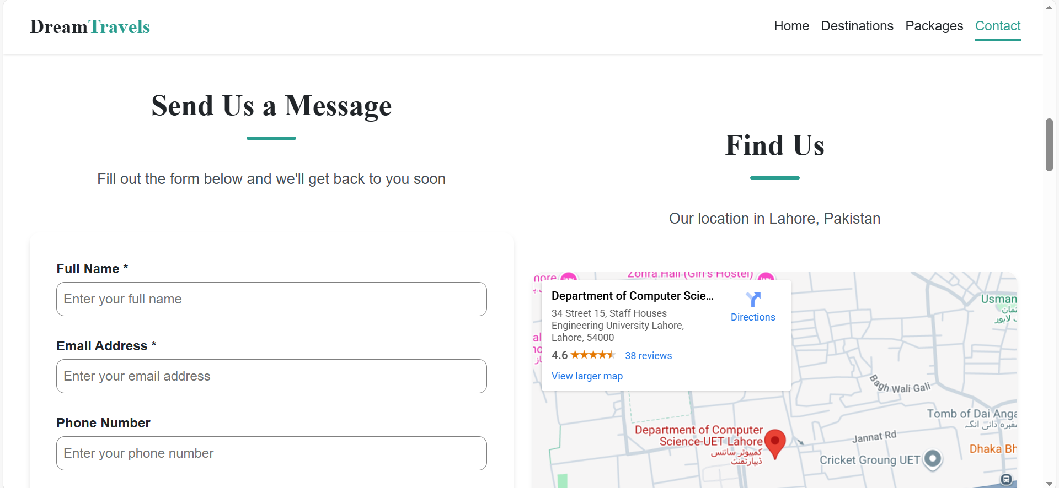

## 

## **7. Conclusion**

The Dream Travel Agency Website project successfully fulfills its objectives by providing a clean, user‑friendly, and informative travel platform. The website helps users explore destinations, select travel packages, and contact the agency easily. This project also improves our understanding of website design, navigation, and professional documentation.